Soldering the Line Following Robot PCB
- Solder the resistors onto the PCB.
  - Bend the leads so that the resitor fits between the holes. The distance between leads at the base of the resistor (the arrow in the diagram) should be about 1/10 of an inch (2.5mm) to fit in the holes.
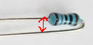
  - Resistors are not polarized (it doesn't matter which direction you solder them on), but for aesthetic reasons, I like to keep them aligned and have the bend on the same side
  - Solder the short side first, then once it is dry, solder the other one. (If you do this in reverse you will likely be burned, since you are holding the resistor in place via the long side)
- Select a Heartbeat LED color (Blue, Green, Yellow, Red, White) and solder it to the board. LEDs are polarized; pay attention to the flat side and align it with the flat side on the PCB's silkscreen. You can optionally sand / file the LED lens to diffuse the light (these are very bright and can be difficult to look at otherwise)
- Solder a button in place.
- Solder the L293D motor driver chip onto the PCB. Note the index marker; the first pin immediately to the left of this is pin 1. Pin numbers continue in a counter clockwise direction from this point:
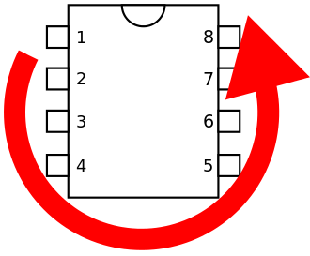
Pin 1 needs to be placed in the pin 1 marker on the PCB (a line above the pad):
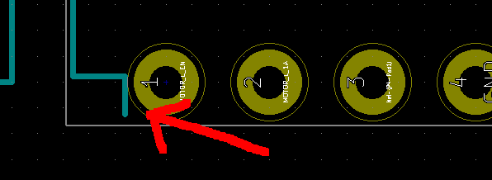
On this PCB, pin1 is the pin closest to the cluster of three 220 ohm resistors in the top left.
- Solder the MCP1702 LDO voltage regulator. Since this board was originally designed for a different voltage regulator, the pins are not aligned. You need to bend the pins to align them. The pinout is shown as follows:
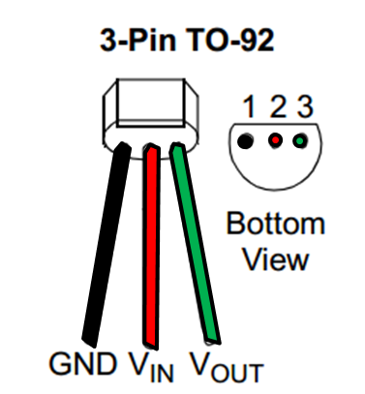
- Solder the female headers in place; this is where the Arduino will be mounted.
  - Cut and file 2x female headers, 12 pins long. To cut the female headers, cut in the middle of the next pin. For instance, if you were to cut a 5 pin length, cut in the middle of pin 6:
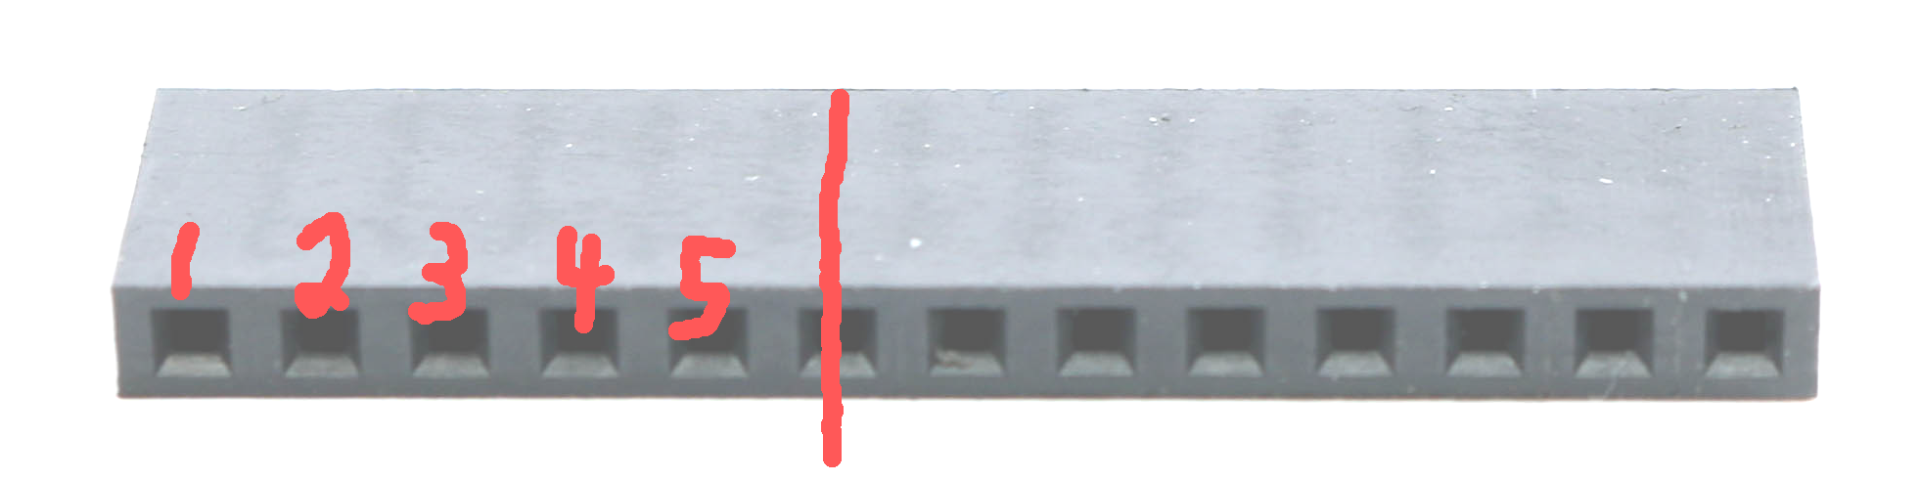
  - Remove the first three pins from one of the headers. These pins will be aligned with TXO, RXI, and RST pins on the Arduino (a.k.a. pins 1, 2, and 3 according to the pin number scheme described above)
  - Solder the headers onto the PCB
- Solder male headers on the Arduino.
  - Solder the 6 pin programming header using the right angle pins
  - Solder the 2x 12 pin GPIO straight headers. You can make sure they are at 90 degrees to the board by putting them into the female headers that you just soldered.
  - Solder a single right angle header to pin A4. Position it so that you can plug in a wire from underneath.
- From underneath the board, solder a jumper wire from pin 1 (TXO) to pin 5 (D2). D2 will now be the MOTOR_L_ENABLE pin.
- From underneath the board, solder a jumper wire with a single female header to pin 7 (D4). This wire will loop around the board and be plugged into the right angle header connected to A4.
- Solder the IR LEDs to the bottom (D1 - D5). Be sure to align the flat portion of the LED with the flat side of the silkscreen.
- Solder the IR photo transistors (Q1 – Q5). Be sure to align the flat portion of the transistor with the flat side of the silkscreen.
- Solder male headers on the motor holes.
- Solder the battery packs together in series (red wire on one to the black wire on the other), and solder the remaining wires to the battery marker on the board. The red wire goes to +, and black to the other one.
- With a multimeter in continuity mode, verify that there are no shorts across +BATT, +5, and GND.
- Remove the Arduino, put in batteries, and use a multimeter in DC voltage mode to verify that there is +5V potential between +5V and GND pins.
- Plug in the Arduino and verify that the light is flashing (default sketch is blinky lights).

